**Visual Merchandising**

Visual Merchandising is the creation of an exceptional atmosphere marked with an extraordinary ambience that resonates with the brand’s identity, ensuring optimal presentation of products to induce sales. The appeal of luxury resides in its enticing aura of personal indulgence, prestige and glamor. Visual Merchandising helps in the conceptualisation of the abstract ecstasy of luxury and plants it in a space that instantly evokes attention of (even potential) clientele. Visual Merchandising boosts customer engagement by enveloping them in the unique spirit of the label’s character while maximizing the return on commercial retail space.

Louis Vuitton’s communication with its clients- The top 5 positive attributes associated with the louis vuitton brand are fashionable, chic, iconic, trendy and emblematic.

Louis Vuitton’s “Your Loss of Senses” Elevator

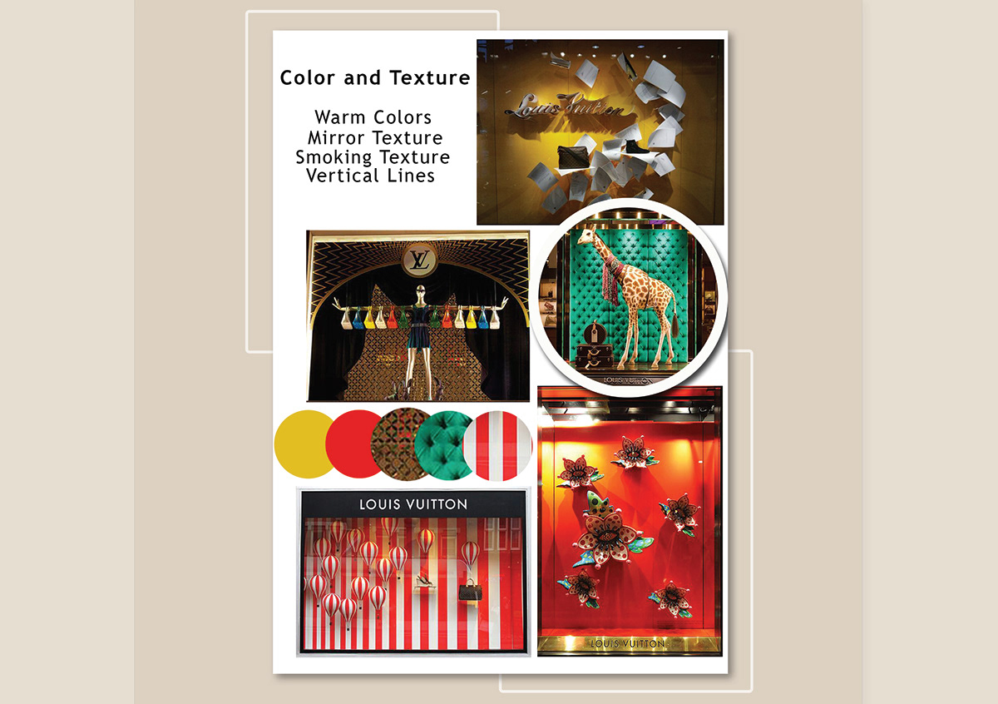

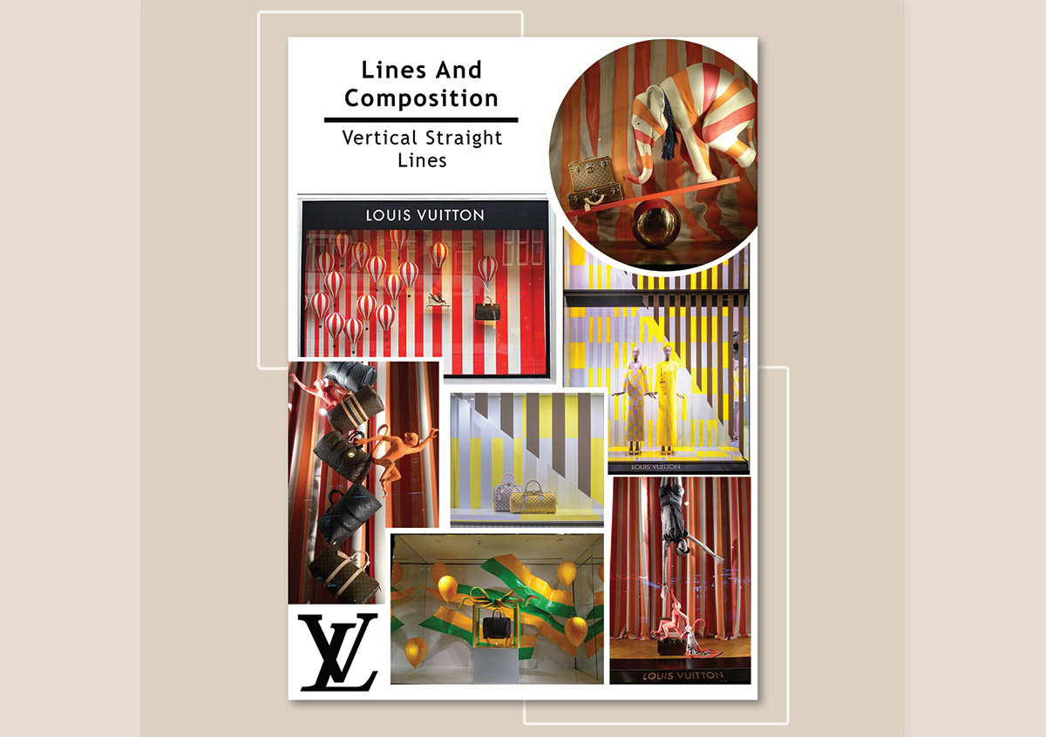

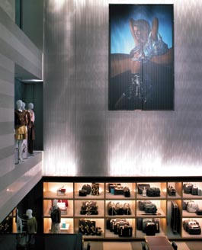

Passersby experience a teasing optical illusion by day and a diffused streetlamp-through-fog appearance by night. Aoki explains how he achieved the effect using laminated strengthened glass with a fine white checkerboard [which Louis Vuitton calls its damier] pattern of ceramic frit on the inner surfaces. There is also a fine checkerboard pattern on the interior face of the laminated glass.

Interior highlights include: a wall of vintage trunks hovering above the periphery of the ground floor dotted with red hat cases and the cantilevered bronze-clad monotube staircase. Hiscoe says, “The precision required for the staircase metal and the southern chestnut treads meant that everything had to be cut perfectly at a facility off-site and trucked in after 10 p.m. and before 6 a.m. So it was always a relief when everything fit together on-site.”

LV reports that the Midtown store is getting double the traffic it had anticipated. And, as Hiscoe says, the building is getting the “wows” LVMH wanted, as well – a word that needs no translation.

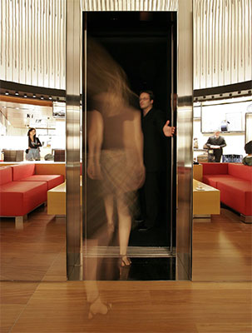

Image Courtesy : Architectural Digest

**Louis Vuitton’s flagship store on the Champs-Élysées in Paris** underwent a massive makeover in 2005. Crafted as a stand-alone art piece in the luxury retailer that is in itself a work of art, Danish artist Olafur Eliasson, decided to build an elevator that would enhance the comprehensive appeal of the establishment. The elevator immersed the customer in a total absence of light and absolute silence - an antithesis of what visual merchandising generally emulates. The space created a 20 second void that repealed all sensual stimulation so when the doors open, the client is primed to intake and fully enjoy the plush and luscious surroundings. Although Your Loss of Senses has been removed now, the elevator still generates much excitement and buzz.

**Hermès’ communication with its clients**

Brand communication and marketing strategies of Hermès always remain consistent with the principles of “heritage” and “exclusivity” of the company. Marketing campaigns celebrate the Hermès lifestyle and do not aim to directly sell products from the various ateliers. The company also sponsors events that have a direct fit with the image and the legacy of the company. In addition to these, Hermès uses strategic collaborations with independent artists and designers to raise visibility of its products. The primary aim of collaborations is to strengthen the aura of exclusivity around specific product portfolios. This is done through the classic “limited edition” strategy, but in the case of Hermès, it puts a higher degree of exclusivity to the portfolio, because Hermès products in themselves are exclusive.

In sync with the company’s heritage and association with horses (and the fact that the company was founded as a saddlery manufacturer), Hermès sponsors lots of horse racing events around the world. In the beginning of 2014, it became the official sponsor of the US Show Jumping Team. The company’s flagship event in the equestrian world is the annual Saut Hermès show-jumping competition held in Paris. Hermès has been organizing and managing this event on its own since 2010 and uses it as an avenue to showcase its fine leather products and its longstanding association with horses. It is also a visibility-generating avenue for Hermès among the very affluent audience of such events.

**Hèrmes’ “Eternal Jungle” Window Display**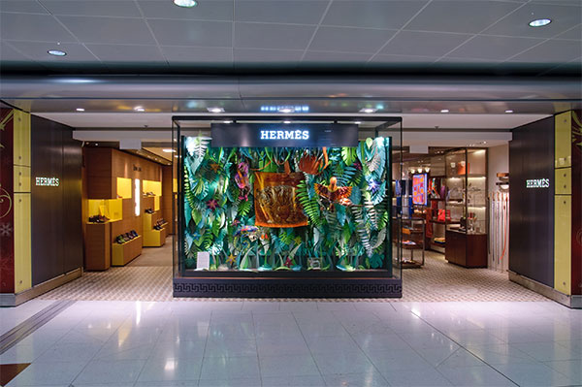

Image Courtesy : Behance

The Hèrmes Store at Hong Kong International Airport exhibited the “Eternal Jungle” creation by designers Lucie Thomas and Thibault Zimmermann of French art studio Zim & Zou. The artists made use of PEFC paper sheets - an environmentally conscious and yet, a delicate and adaptable material - to create the jungle, full of vegetation indigenous to Hong Kong, made of 600 leaves. They used carefully selected leather cut-offs from the Hèrmes workshops to design the inhabitants of this jungle - a money, a toucan and a chameleon. The artwork had been handcrafted with the utmost attention to detail with more than 200 hours of work going into the creation of each animal. The entire display presented the onlooker with an exciting invitation into the refined world of the wild.

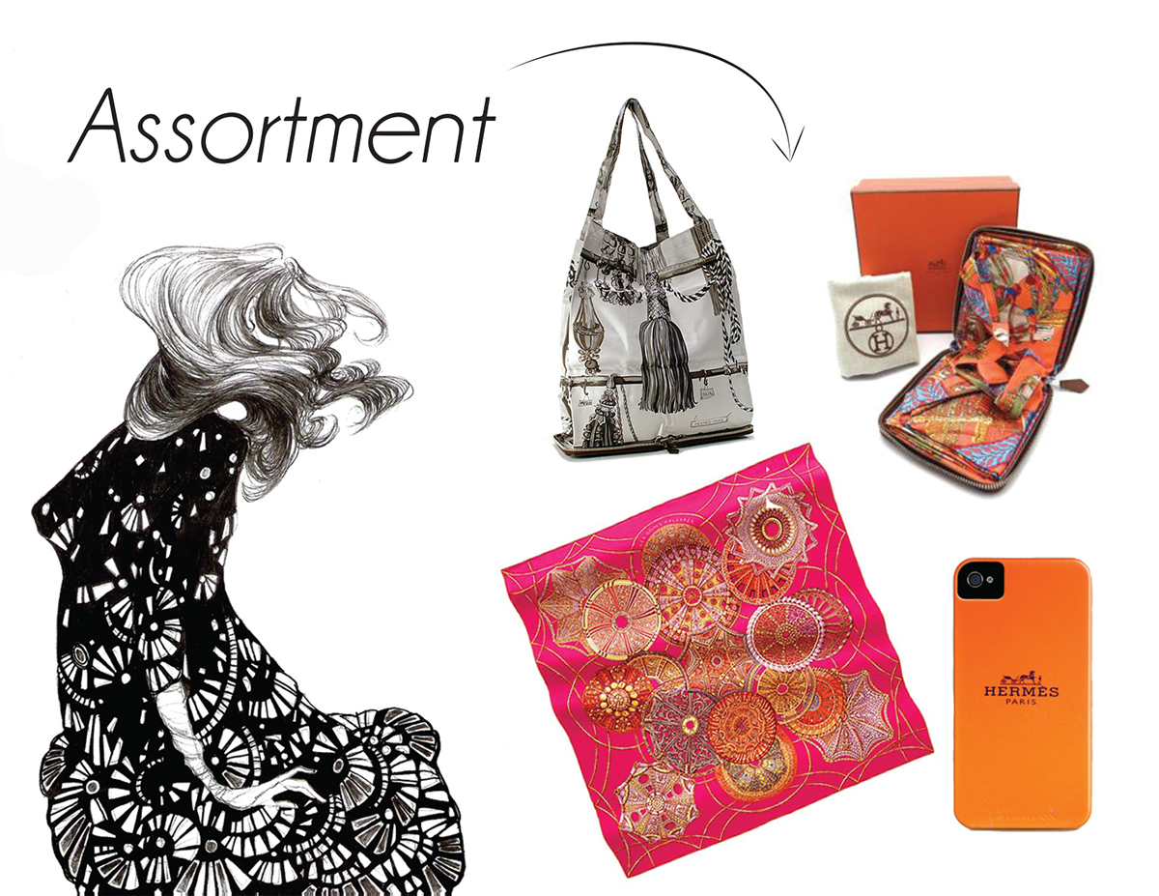

The **Hermès pop-up shop assortment of merchandise** will include items that are relatively small, practical and easy to incorporate into an existing outfit such as scarves, fold-out tote bags and iPhone cases.

